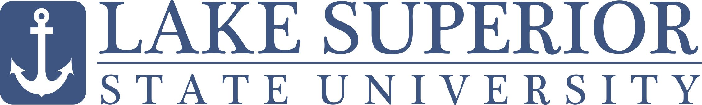 | Business Operations  EFT Authorization Form

Please check one: New authorization Change of information on existing authorization

Vendor Information

Check one to identify your status: Employee Student Supplier

Name
 | Last | First | MI

LSSU ID:
  A

E-mail |  | @

Phone | ( ) | ( )
 | Campus | Home

Financial Institution Information

Bank Name

Bank Address
 | City | State / Province

 | 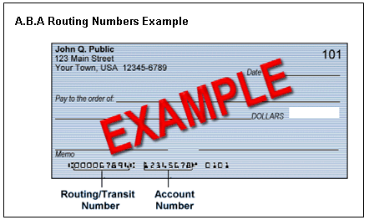
  Routing number
  Account number
  Type of account | Checking Savings

By signing below, I indicate that:  - I request and authorize Lake Superior State University (LSSU) to deposit any reimbursements or other approved payments into my account with the financial institution indicated above.  - This authorization will remain in full force and effect for the duration of my employment, or until LSSU discontinues the service, or until I submit a written request to terminate the service. I will submit this request to the Business Operations office in a timely manner as to afford LSSU and my financial institution a reasonable opportunity to act upon my request.  - Sole notification of my EFT payment will be delivered to the e-mail address indicated above. | Please return completed form and  return with a voided check to:  Lake Superior State University  Attn: Accounts Payable  650 W. Easterday Ave.  Sault Sainte Marie, MI 49783  Fax (906) 635-6669
Signature Date | Form revised 02/11

